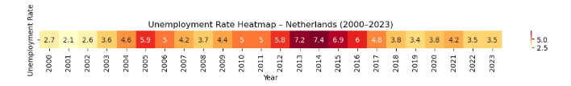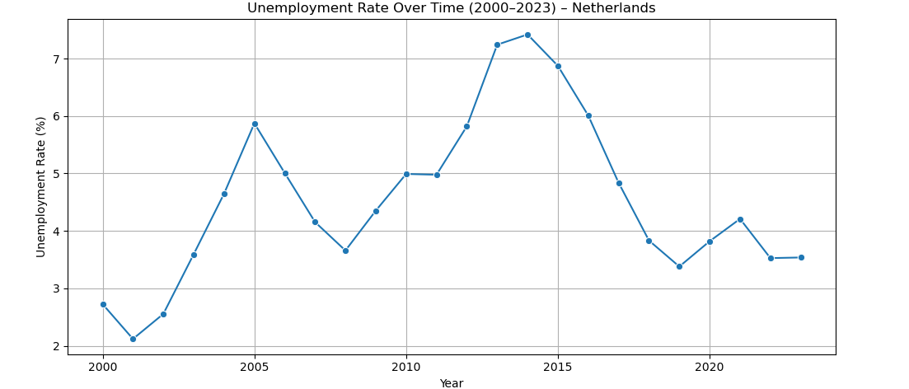

This line graph and the heatmap above illustrate unemployment trends between 2000 and 2023 in the Netherlands, derived from data collected from the World Bank. The line graph allows the observers to examine the unemployment trends in general and highlight the lowest and highest points as well as the fluctuations. In addition, the heatmap illustrates the exact numerical rates of unemployment in the Netherlands between 2000 and 2023, allowing for an in depth examination of unemployment trends.

From a broader perspective, the Netherlands experienced relatively low unemployment throughout the observed period, fluctuating between a minimum of 2.1% in 2001 and a peak of 7.4% in 2014. The early 2000s were marked by stable and low unemployment rates, but a steady increase can be observed from 2003 onward, with another noticeable rise starting around 2011. This aligns with the aftermath of the 2008 financial crisis, where many EU countries faced increased unemployment due to slowed economic growth. The Netherlands’ unemployment peaked in 2014, before beginning a consistent decline.

Following 2015, a downward trend is visible, reaching 3.4% in 2019. Although the COVID-19 pandemic in 2020 caused a temporary rise to 3.8% and 4.2% in 2021, the unemployment rate returned to 3.5% by 2023. This reflects the Netherlands' resilience and effective labor market policies.

Overall, the trend indicates a stable and responsive economy, capable of recovery after global economic shocks, with strong employment dynamics across two decades.